

**Send Email Configuration Document**

**Created By: QA Team**

**Created On: 20-11-2023**

**Send Email Configuration setup:**

1. **CONNECTED APP CREATION IN SALESFORCE ORG:**

From the salesforce setup, search for APPS

Click on **CREATE APPS** and enter the following details:

1. **Connected App Name** <Can be any name>
2. **API Name** <Auto generated>
3. **Contact Email** <Required Email address>
4. **Enable OAuth Settings** <True>
5. **Callback URL**<Any URL>
   1. For Eg: https://
6. **Selected OAuth Scopes**
   1. Manage user data via APIs (api).
   2. Perform request at any time (refresh_token,offline-access).
7. **Disable the following checkboxes:**
   1. Require proof key for code exchange(PKCE) extension for supported authorization flows.
   2. Require secret for refresh token flow.
8. Click on **Save** button.

After Creating the Connected apps, we will get the ClientId and SecretId.

**2. EXECUTE THE CODE FROM AN ANONYMOUS WINDOW.**

Below is code snippet to be executed from Execute Anonymous Window--------

**String storageType = 'SharePoint';**

**String clientId = '<CLIENT_ID>';**

**String clientSecret = '<CLIENT_SECRET>';**

**String username = '<USERNAME>';**

**String password = '<PASSWORD+SECURITY_TOKEN>';**

**String loginurl = '**[**https://login.salesforce.com**](https://login.salesforce.com/)**';**

**XFILES.XFP_OAuth.updateOAuthInfo(storageType, clientId, clientSecret, username, password, loginUrl);**

Execute the above code successfully.

**3. HOW TO ADD/REMOVE THE OAUTH INFO FROM DEVELOPER CONSOLE?**

In case the user updated the wrong oAuth info, the user can delete the info and re-run the code and update.

The user can do the following steps to update the OAuth info:

1. Go to the “**Developer Console**”.
2. Click on File->Open->Objects->**Cloud_Storage_Provider_c.**
3. Select **Id,name** and **XFILES__OAuth_info__c**.
4. Query and **execute** the query.

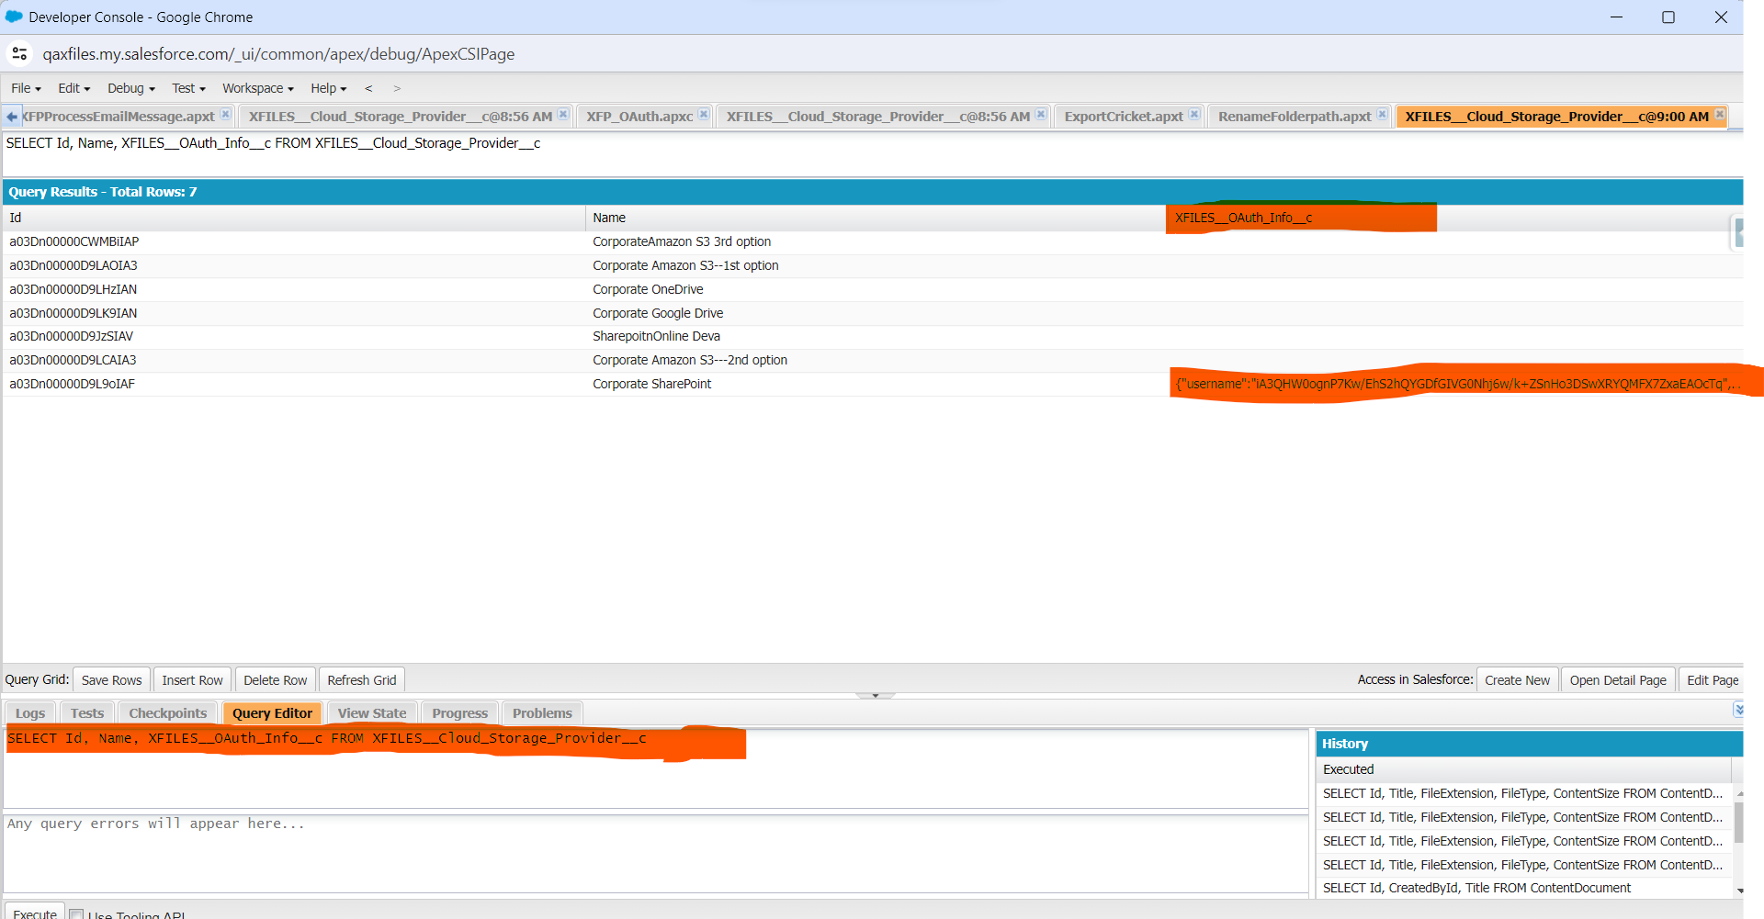

You can see the snippet code which we executed is updated in the **Xfiles__OAuth_info__c .**

If the user needs to make some changes in the info for example , they need to change the clientid, secretid, password etc then they can remove the info and click on “**Save Rows**”.

After saving rows, as per your need make changes in the code and Run the code again in the anonymous window.

So that the **OAuth info** field will get updated with the new changes.

**These are the configurations that need to be done before proceeding with the “Send Email” feature.**